**ROUTE-53**

* Route 53 is a Managed DNS (Domain Name System)
* DNS is a collection of rules and records which helps clients understand how to reach a server through URLs
* In AWS, the most common records are:
* [www.google.com](http://www.google.com) => 12.34.56.78 == A Name Record (IPv4)
* [www.google.com](http://www.google.com) => 2001:0db8:h64g:7452:hgqw:tre1:mn76:qewr == A Name (IPv6)
* Search.google.com => [www.google.com](http://www.google.com) == CNAME: hostname to hostname
* Example.com =>AWS Resource == alias (ex: ELB, CloudFront, S3, RDS etc..)

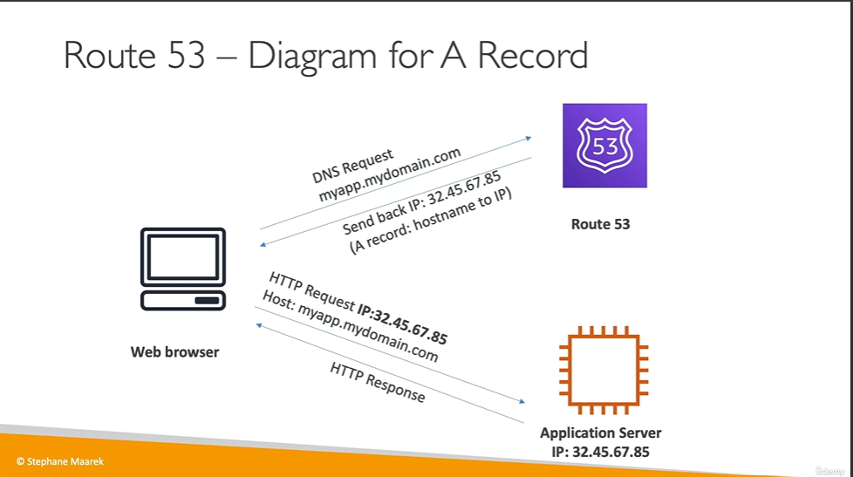

**Route 53 Routing Policies:** (Need to know them at a high level for the CCP exam)

* **Simple Routing Policy:** It has no health checks. It simply does a DNS query and gets a IPv4, for an example.

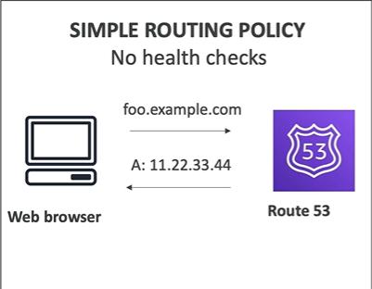

* **Weighted Routing Policy:** This allows us to distribute the traffic among multiple EC2 instances

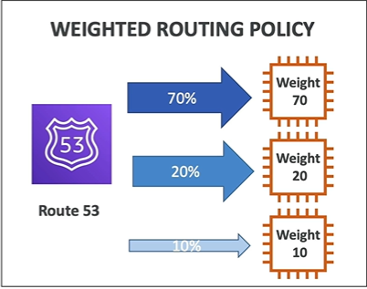

So, in this example, we have to assign weights to our Institute instances, for example, 70, 20, and 10, and then our DNS we'll make sure that our clients have 70% of the traffic onto the first one, 20% of the traffic onto the second one and 10% of the traffic on to the third one.

This is effectively some kind of load balancing. So, in this Weighted Routing Policy, we can use health checks.

* **Latency Routing Policy:** The latency routing policy will look at where the user is located and if they are close to Asia, they will be made to talk to the server in that region. Hence, Route 53 is used to minimise the latency between the users and the servers by making the users connect to the server that is closest to them.

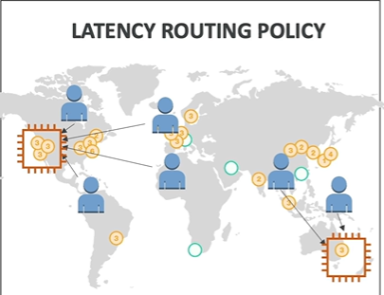

* **Failover Routing Policy:** In this policy, we have a client and we have a primary and a failover (secondary) region. Our DNS system will do a health check on the primary, and in case the primary fails, then we will be redirected to the failovers. (Disaster Recovery). So, the clients will exactly know which instance to connect to based on their health checks.

**NOTE:** Route 53 doesn’t provide DDoS protection